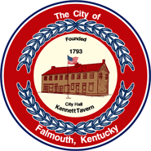 | CITY OF FALMOUTH  230 Main Street  Falmouth, Kentucky 41040  Phone (859) 654-6937 Fax (859) 654-3603  Interim Mayor Luke Price  lprice@cityoffalmouth.com  City Clerk/Treasurer Susan L. Bishop  sbishop@cityoffalmouth.com | Council Members  Joyce Carson  Sabrina Hazen  Amy Hurst  David Klaber  Bob Pettit

CITY COUNCIL MEETING
6:30 PM

February 6, 2024

SPECIAL

AGENDA

- Call to Order
- Pledge of Allegiance
- Invocation
- Discussion and Appointment of Councilmember
- First Reading Ordinance 2024.1 Council meeting date change
- First Reading Ordinance 2024.2 Telecommunication Franchise Agreement
- Closed Session per KRS 61.810 (1)(c) discussion of Ernst vs City of Falmouth
- Adjournment

Caucus Meeting will convene after adjournment of Special Meeting.

